Practical-2

1. CREATE USER. COMMAND:

db.createUser({ user: "AMIT", pwd: "123",

roles:[{role: "userAdminAnyDatabase" , db:"admin"}]

})

Output:

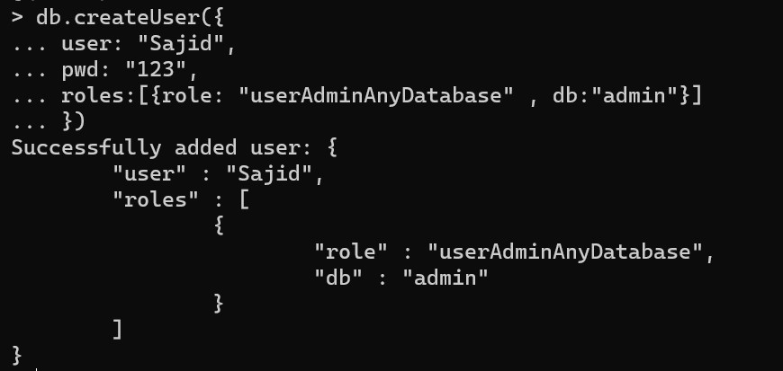

1. CREATE DATABASE Use emp COMMAND:

use test

OUTPUT:



1. CREATE COLLECTION

COMMAND:

db.createCollection("std_004")

OUTPUT:

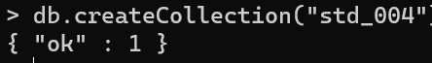

1. INSERT DATA INTO DATABASE OUTPUT:

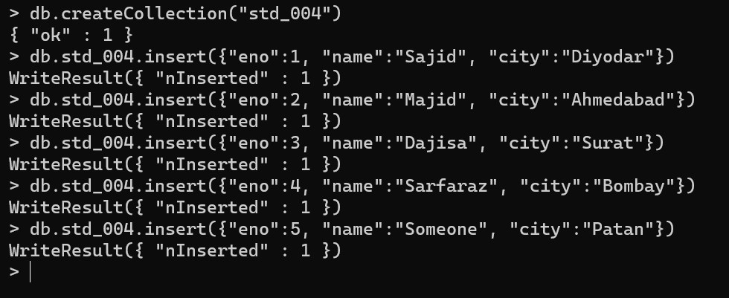

1. UPDATE AND DELETE DATA COMMAND: Update:

db.std_004.update({“eno”:2},{$set:{“name”:”Majid”}})

OUTPUT:

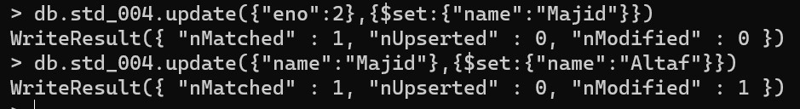

Delete: db.std_004.remove({eno:2})

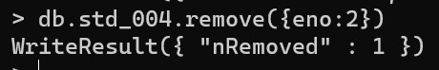

1. RETRIVAL OF DATA COMMAND:

db.std_004,find().forEach(printjson) OUTPUT:

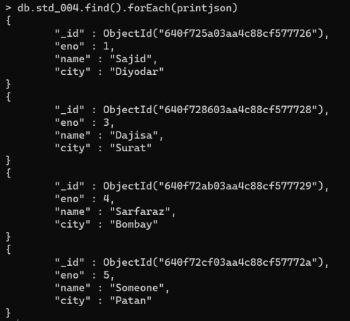

1. COMMAND:

db.std_004.find({name : “Sarfaraz”} ).forEach(printjson)

OUTPUT:

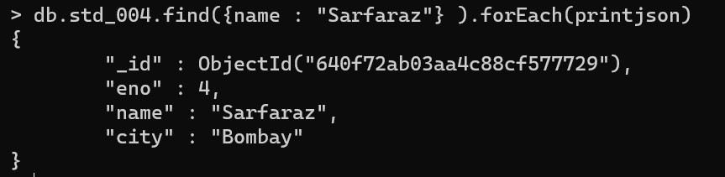

1. COMMAND:

db.std_004.find({eno : {$gt:2}})

OUTPUT:



1. DISPLAY DATABASE COMMAND: Show dbs

OUTPUT:

